Sen^2 α + cos^2 α = 1  FUNCIONES TRIGONOMÉTRICAS |  | Sen 2α = 2 sen α cos α  Montoya.
Cos 2α = cos^2 α − sen^2 α | A = B = C = 2Re  Sen A sen B sen C
Cos 2 α = 2 cos^ 2 α − 1 | A^2 = B^2 + C^2 – 2BC cos α
A-B = tg(A-B) /2  A+B tg(A+B) /2 | C= A cos β + B cos α
Tg α+β = tg α + β  1 + tgα tgβ | Tg 2 α =2 tg α  1− tg^2 α

 | Sen α | Cos α | Tg α | Ctg α | Sec α | Csc α
Sen α |  | √(1-cos^2 α) | Tg α  √(1+tg^2 α) | 1_____  √(1+ctg^2 α) | √(sec^2 α − 1)  sec α | 1___  csc α
Cos α | √(1- sen^2 α) |  | 1_____  √(1+tg^2 α) | ctg α  √(1+ctg^2 α) | 1_____  sec α | √(csc^2 α −1)  csc α
Tg α | Sen α  √(1- sen^2 α) | √(1- cos^2 α)  cos α |  | 1____  ctg α | √(sec^2 α-1) | 1_____  √(csc^2 α-1)
Ctg α | √(1- sen^2 α)  sen α | Cos α  √(1- cos^2 α) | 1____  tg α |  | 1____  √(sec^2 α-1) | √(csc^2 α-1)
Sec α | 1_____  √(1- sen^2 α) | _____1____  cos α | √(1 + tg^2 α) | √(1+ctg^2 α)  ctg α |  | ____csc_α_ _  √(csc^2 α-1)
Csc α | 1____  sen α | 1  √(1- cos^2 α) | √(1+tg^2 α)  tg α | √(1+ctg^2 α) | Sec _α_  √(sec^2 α-1)

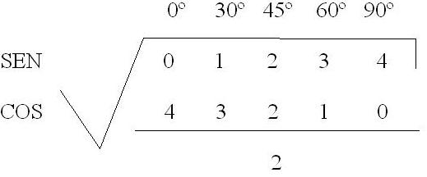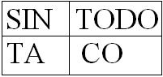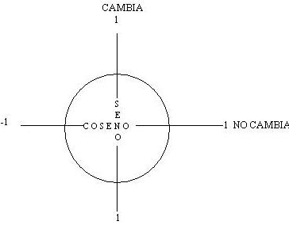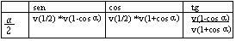Sen (α + β) = sen α cos β + sen α cos β | Cos (α + β) = cosα cosβ – senα senβ

Triangulo |  | Polígono
A = ½ ac sen β | RA = A_  p - a | Ai = ½ R^2 sen (2π/n)
Ri = A/p | A = ½ a^2 sen Β sen C  Sen (B+C) | Pi = 2 n R sen (π/n)
Re= abc  4A | Pe = 2n R tg (π/n)  (Poligono) | Ae = n R^2 tg (π/n)

